

Foundations of Programming
Assignment No. : 10

PROBLEM STATEMENT:
Write a program in C to simulate a simple calculator that performs basic arithmetic operations such as addition, subtraction, multiplication, and division. The calculator should also perform special operations like computing xʸ (power) and x! (factorial).

OBJECTIVE:
• To understand the use of switch-case statements in C.
• To perform basic arithmetic and special mathematical operations.
• To enhance problem-solving skills using menu-driven programs.

THEORY:
A calculator is a basic computing device used to perform arithmetic operations. In C programming, a simple calculator can be implemented using conditional or switch-case statements. Arithmetic operations like addition, subtraction, multiplication, and division are fundamental operations. Special operations such as power (xʸ) and factorial (x!) require loops for repeated calculations.

PLATFORM:
Linux

ALGORITHM:

C PROGRAM:

INPUT:
User selects an operation from the menu and enters required values.
Example Input:
Choice: 1
Numbers: 10 20
Screen Shot of Input

OUTPUT:
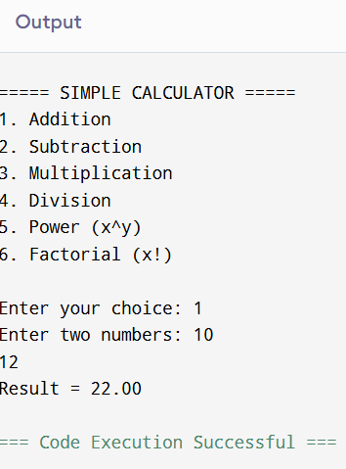
Example Output:
Result = 22.00
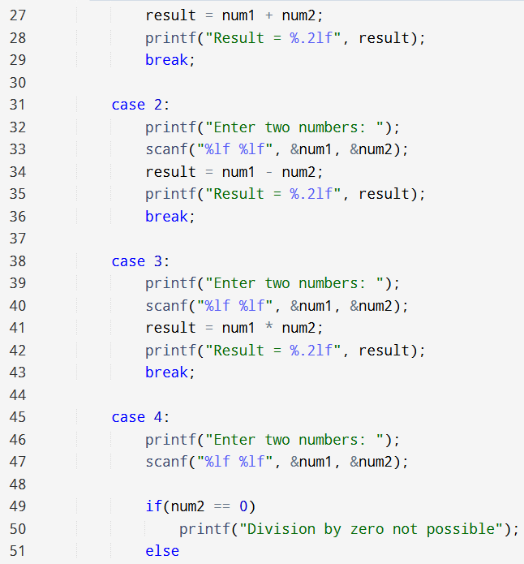
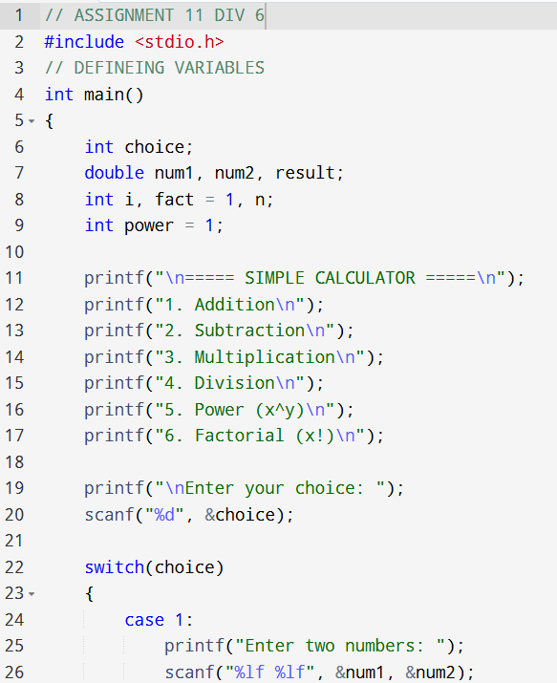
CODE:
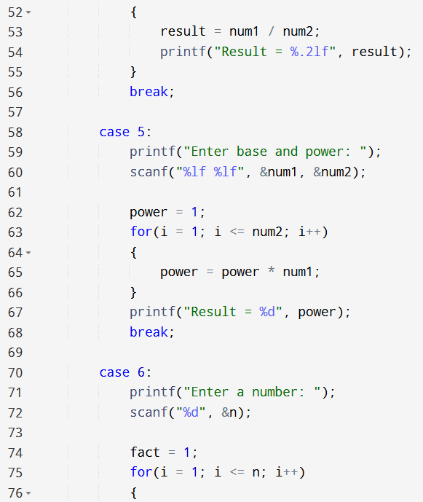

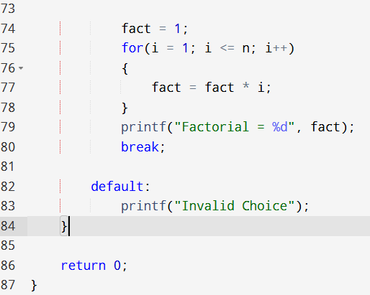

CONCLUSION:
Thus, a simple calculator program was successfully implemented using C programming. The program demonstrates the use of switch-case statements, loops, and arithmetic operations.

FAQs:
- What is a simple calculator program?
- Why is switch–case preferred in calculator programs?
- How does the program handle division by zero?
- How is the power operation (xʸ) implemented without using math library functions?
- What is factorial and how is it calculated using loops in C?

FLOWCHART:
